Georg Friedrich Händel, Jephtha (1751), Akt II, Schluss (Text: Thomas Morell)
Rezitativ & Arie (Iphis)
Such news flies swift; I’ve heard the mournful cause of all our sorrows. Of my father’s vow, heav’n spoke approbation by success. Jephtha hath triumph’d. – Israel is free! For joys so vast, too little is the price of one poor life – but oh! Accept it, heav’n a grateful victim, and thy blessings still pour on my country, friends, and dearest father.
Happy they: this vital breath / with content I shall resign; / and not murmur, or repine / sinking in the arms of death.
Rezitativ Accompagnato (Jephtha)
Deeper, and deeper still, thy goodness, child, pierceth a father’s bleeding heart, and checks the cruel sentence on my falt’ring tongue. Oh! Let me whisper it to the raging winds, or howling deserts; for the ears of men it is too shocking. – Yet, have I not vow’d? And can I think the great Jehovah sleeps, like Chemosh, and such fabled deities? Ah! No; heav’n heard my thoughts, and wrote them down – it must be so. – ‘Tis this that racks my brain, and pours into my breast a thousand pangs, that lash me into madness. – Horrid thought! – My only daughter! – so dear a child, doom’d by a father! – Yes, the vow is past, and Gilead hath triumph’d o’er his foes. – Therefore, to-morrow’s dawn – I can no more.
Chor
How dark, o Lord, are Thy decrees! / All hid from mortal sight! / All our joys, to sorrow turning, / and our triumphs into mourning, / as the night succeds the day. / No certain bliss, / no solid peace, / we mortals know, / on earth below. / Yet on this maxim still obey. / Whatever is, is right.

Iphis: Reri Grist (Sopran) – Jephtha: Alexander Young (Tenor) – Amor Artis Chorale – English Chamber Orchestra – Dirigent: Johannes Somary (Aufnahme: 1969)
Georg Friedrich Händel (1685–1759)
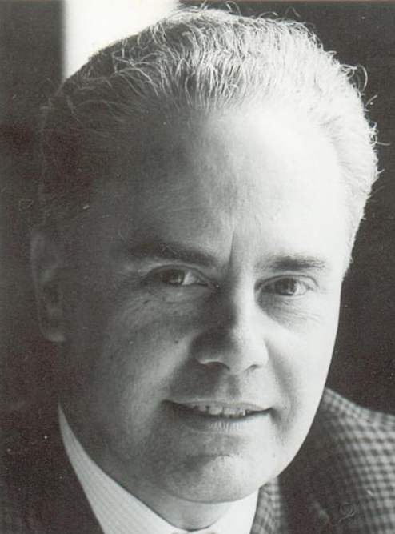
Reri Grist (*1932) Alexander Young (1920–2000)

