## Name: Klasse 7 .09.2023 A

# Mathematikarbeit Nr. 1 - Thema: Zuordnungen

#### Basisaufgaben

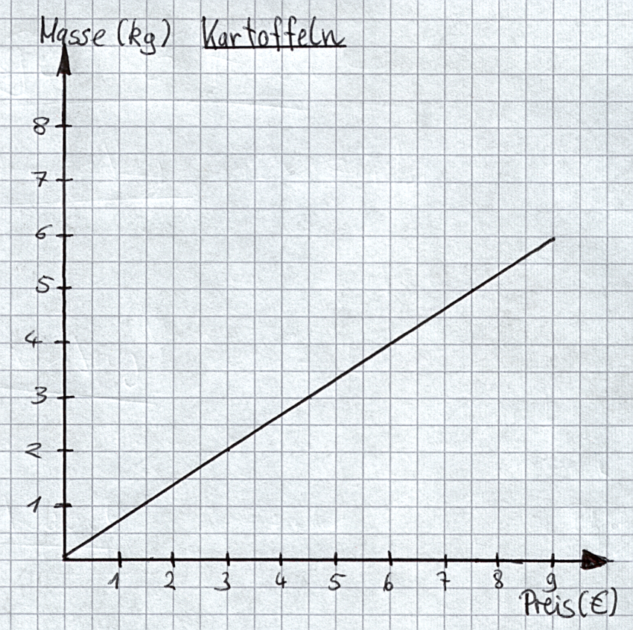**1.) Lies die Werte aus dem Graphen der Zuordnung ab.**

|  |  |  |  |  |
| --- | --- | --- | --- | --- |
| **€** | 3 | 4,5 | 7,5 | 9 |
| **kg** |  |  |  |  |

|  |  |  |  |  |
| --- | --- | --- | --- | --- |
| **kg** | 1 | 3 | 4 | 6 |
| **€** |  |  |  |  |

### 8 P./ _____

**2.) Berechne die fehlenden Größen der proportionalen Zuordnung.**

|  |  |  |  |  |
| --- | --- | --- | --- | --- |
| **Glühlampen** | **Preis (€)** |  | **Paar Socken** | **Preis (€)** |
| 6 | 3 |  | 8 | 24 |
| 30 |  |  | 16 |  |
| 60 |  |  | 40 |  |
| 5 |  |  | 4 |  |

**6 P. /_____**

**3.) Berechne die fehlenden Größen der antiproportionalen Zuordnung.**

|  |  |  |  |  |
| --- | --- | --- | --- | --- |
| **Bagger** | **Tage** |  | **Arbeiter** | **Stunden** |
| 8 | 6 |  | 9 | 4 |
| 16 |  |  | 3 |  |
| 4 |  |  | 6 |  |
| 12 |  |  | 12 |  |

**6 P. /_____**

|  |  |  |  |  |  |  |  |
| --- | --- | --- | --- | --- | --- | --- | --- |
| **4.) a) 3 Pumpen benötigen 24 h, um den Keller**  **leerzupumpen. Wie lange brauchen 8 Pumpen  dafür?** (antiproportionale Zuordnung) | | | | **b) Frau Meier hat im Urlaub für 14 Tage 280 € bezahlt. Wie vielEuro muss Herr Lohe in derselben Pension für 8 Tage bezahlten? (proportionale Zuordnung)** | | | |
| **Pumpen** | **Stunden** |  | | **Tage** | **€** |
| 3 | 24 |  | | 14 | 280 |
| 1 |  |  | | 1 |  |
| 8 |  |  | | 9 |  |

### 4 P./ _____

## Erweiterungsaufgaben

**5.) Ist die Zuordnung proportional, antiproportional oder nicht proportional? Begründe deine Antwort.**

|  |  |  |  |  |  |  |  |  |  |  |
| --- | --- | --- | --- | --- | --- | --- | --- | --- | --- | --- |
| **Anzahl** | | **Zeit** |  | **Entfernung** | | **Preis** |  | **Gewicht** | **Preis** | |
| 4 Personen | | 12 h |  | 2 km | | 2,20 € |  | 500g | 1,90 € | |
| 2 Personen | | 24 h |  | 6 km | | 4,60 € |  | 1,5 kg | 5,70 € | |
| 6 Personen | | 8 h |  | 8 km | | 5,80 € |  | 250 g | 0,95 € | |
|  | Die Zuordnung ist  ____________________  _______________, weil ____________________  ____________________  ____________________. | |  |  | Die Zuordnung ist  ____________________  _______________, weil ____________________  ____________________  ____________________. | |  | Die Zuordnung ist  ____________________  _______________, weil ____________________  ____________________  ____________________. | |  |

### 6 P./_____

|  |  |  |  |  |  |  |  |  |  |  |  |  |  |  |  |  |  |  |  |  |  |  |  |  |  |  |  |  |  |  |  |  |  |  |  |  |  |  |  |  |  |  |  |  |  |  |  |  |  |  |  |  |  |  |  |  |  |  |  |  |  |  |  |  |  |  |  |  |  |  |  |  |  |  |  |  |  |  |  |  |  |  |  |  |  |  |  |  |  |  |  |  |  |  |  |  |  |  |  |  |  |  |  |  |  |  |  |  |  |  |  |  |  |  |  |  |  |  |  |  |  |  |  |  |  |  |  |  |  |  |  |  |  |  |  |  |  |  |  |  |  |  |  |  |  |  |  |  |  |  |  |  |  |  |  |  |  |  |  |  |  |  |  |  |  |  |  |  |  |  |  |  |  |  |  |  |  |  |  |  |  |  |  |  |  |  |  |  |  |  |  |  |  |  |  |  |  |  |  |  |  |  |  |  |  |  |  |  |  |  |  |  |  |  |  |  |  |  |  |  |  |  |  |  |  |  |  |  |  |  |  |  |  |  |  |  |  |  |  |  |  |  |  |  |  |  |  |  |  |
| --- | --- | --- | --- | --- | --- | --- | --- | --- | --- | --- | --- | --- | --- | --- | --- | --- | --- | --- | --- | --- | --- | --- | --- | --- | --- | --- | --- | --- | --- | --- | --- | --- | --- | --- | --- | --- | --- | --- | --- | --- | --- | --- | --- | --- | --- | --- | --- | --- | --- | --- | --- | --- | --- | --- | --- | --- | --- | --- | --- | --- | --- | --- | --- | --- | --- | --- | --- | --- | --- | --- | --- | --- | --- | --- | --- | --- | --- | --- | --- | --- | --- | --- | --- | --- | --- | --- | --- | --- | --- | --- | --- | --- | --- | --- | --- | --- | --- | --- | --- | --- | --- | --- | --- | --- | --- | --- | --- | --- | --- | --- | --- | --- | --- | --- | --- | --- | --- | --- | --- | --- | --- | --- | --- | --- | --- | --- | --- | --- | --- | --- | --- | --- | --- | --- | --- | --- | --- | --- | --- | --- | --- | --- | --- | --- | --- | --- | --- | --- | --- | --- | --- | --- | --- | --- | --- | --- | --- | --- | --- | --- | --- | --- | --- | --- | --- | --- | --- | --- | --- | --- | --- | --- | --- | --- | --- | --- | --- | --- | --- | --- | --- | --- | --- | --- | --- | --- | --- | --- | --- | --- | --- | --- | --- | --- | --- | --- | --- | --- | --- | --- | --- | --- | --- | --- | --- | --- | --- | --- | --- | --- | --- | --- | --- | --- | --- | --- | --- | --- | --- | --- | --- | --- | --- | --- | --- | --- | --- | --- | --- | --- | --- | --- | --- | --- | --- | --- | --- | --- | --- | --- | --- | --- | --- | --- | --- | --- | --- | --- | --- |
| **6.) a) 8 Arbeiter heben einen Graben in 6 Tagen aus.** Wie lange würden 12 Arbeiter brauchen?(antiproportionale Zuordnung)  |  |  |  |  |  |  |  |  |  |  |  |  |  |  |  |  | | --- | --- | --- | --- | --- | --- | --- | --- | --- | --- | --- | --- | --- | --- | --- | --- | |  |  |  |  |  |  |  |  |  |  |  |  |  |  |  |  | |  |  |  |  |  |  |  |  |  |  |  |  |  |  |  |  | |  |  |  |  |  |  |  |  |  |  |  |  |  |  |  |  | |  |  |  |  |  |  |  |  |  |  |  |  |  |  |  |  | |  |  |  |  |  |  |  |  |  |  |  |  |  |  |  |  | |  |  |  |  |  |  |  |  |  |  |  |  |  |  |  |  | |  |  |  |  |  |  |  |  |  |  |  |  |  |  |  |  | |  |  |  |  |  |  |  |  |  |  |  |  |  |  |  |  | | |  |  |  |  |  |  |  |  |  |  |  |  |  |  |  | | --- | --- | --- | --- | --- | --- | --- | --- | --- | --- | --- | --- | --- | --- | --- | |  |  |  |  |  |  |  |  |  |  |  |  |  |  |  | |  |  |  |  |  |  |  |  |  |  |  |  |  |  |  | |  |  |  |  |  |  |  |  |  |  |  |  |  |  |  | |  |  |  |  |  |  |  |  |  |  |  |  |  |  |  | |  |  |  |  |  |  |  |  |  |  |  |  |  |  |  | |  |  |  |  |  |  |  |  |  |  |  |  |  |  |  | |  |  |  |  |  |  |  |  |  |  |  |  |  |  |  | |  |  |  |  |  |  |  |  |  |  |  |  |  |  |  |   **b) 9 Brötchen kosten 1,80 €. Wie teuer sind 15 Brötchen? (proportionale Zuordnung)** |

### 6 P./ _____

**7.) Überlege zuerst, ob es sich um eine proportionale oder eine antiproportionale Zuordnung handelt und berechne dann.**

|  |  |  |  |  |  |  |  |  |  |  |  |  |  |  |  |  |  |  |  |  |  |  |  |  |  |  |  |  |  |  |  |  |  |  |  |  |  |  |  |  |  |  |  |  |  |  |  |  |  |  |  |  |  |  |  |  |  |  |  |  |  |  |  |  |  |  |  |  |  |  |  |  |  |  |  |  |  |  |  |  |  |  |  |  |  |  |  |  |  |  |  |  |  |  |  |  |  |  |  |  |  |  |  |  |  |  |  |  |  |  |  |  |  |  |  |  |  |  |  |  |  |  |  |  |  |  |  |  |  |  |  |  |  |  |  |  |  |  |  |  |  |  |  |  |  |  |  |  |  |  |  |  |  |  |  |  |  |  |  |  |  |  |  |  |  |  |  |  |  |  |  |  |  |  |  |  |  |  |  |  |  |  |  |  |  |  |  |  |  |  |  |  |  |  |  |  |  |  |  |  |  |  |  |  |  |  |  |  |  |  |  |  |  |  |  |  |  |  |  |  |  |  |  |  |  |  |  |  |  |  |  |  |  |  |  |  |  |  |  |  |  |  |  |  |  |  |  |  |  |
| --- | --- | --- | --- | --- | --- | --- | --- | --- | --- | --- | --- | --- | --- | --- | --- | --- | --- | --- | --- | --- | --- | --- | --- | --- | --- | --- | --- | --- | --- | --- | --- | --- | --- | --- | --- | --- | --- | --- | --- | --- | --- | --- | --- | --- | --- | --- | --- | --- | --- | --- | --- | --- | --- | --- | --- | --- | --- | --- | --- | --- | --- | --- | --- | --- | --- | --- | --- | --- | --- | --- | --- | --- | --- | --- | --- | --- | --- | --- | --- | --- | --- | --- | --- | --- | --- | --- | --- | --- | --- | --- | --- | --- | --- | --- | --- | --- | --- | --- | --- | --- | --- | --- | --- | --- | --- | --- | --- | --- | --- | --- | --- | --- | --- | --- | --- | --- | --- | --- | --- | --- | --- | --- | --- | --- | --- | --- | --- | --- | --- | --- | --- | --- | --- | --- | --- | --- | --- | --- | --- | --- | --- | --- | --- | --- | --- | --- | --- | --- | --- | --- | --- | --- | --- | --- | --- | --- | --- | --- | --- | --- | --- | --- | --- | --- | --- | --- | --- | --- | --- | --- | --- | --- | --- | --- | --- | --- | --- | --- | --- | --- | --- | --- | --- | --- | --- | --- | --- | --- | --- | --- | --- | --- | --- | --- | --- | --- | --- | --- | --- | --- | --- | --- | --- | --- | --- | --- | --- | --- | --- | --- | --- | --- | --- | --- | --- | --- | --- | --- | --- | --- | --- | --- | --- | --- | --- | --- | --- | --- | --- | --- | --- | --- | --- | --- | --- | --- | --- | --- | --- | --- | --- | --- | --- | --- | --- | --- | --- | --- | --- |
| **a) 9 Arbeiter erledigen die Ernte in 3 Tagen .** Wie lange würden 12 Arbeiter brauchen?  |  |  |  |  |  |  |  |  |  |  |  |  |  |  |  |  | | --- | --- | --- | --- | --- | --- | --- | --- | --- | --- | --- | --- | --- | --- | --- | --- | |  |  |  |  |  |  |  |  |  |  |  |  |  |  |  |  | |  |  |  |  |  |  |  |  |  |  |  |  |  |  |  |  | |  |  |  |  |  |  |  |  |  |  |  |  |  |  |  |  | |  |  |  |  |  |  |  |  |  |  |  |  |  |  |  |  | |  |  |  |  |  |  |  |  |  |  |  |  |  |  |  |  | |  |  |  |  |  |  |  |  |  |  |  |  |  |  |  |  | |  |  |  |  |  |  |  |  |  |  |  |  |  |  |  |  | |  |  |  |  |  |  |  |  |  |  |  |  |  |  |  |  | | b) 13 kg Kartoffeln kosten 19,50 €.  Wie viel muss man für 9 kg Kartoffeln bezahlen?  |  |  |  |  |  |  |  |  |  |  |  |  |  |  |  | | --- | --- | --- | --- | --- | --- | --- | --- | --- | --- | --- | --- | --- | --- | --- | |  |  |  |  |  |  |  |  |  |  |  |  |  |  |  | |  |  |  |  |  |  |  |  |  |  |  |  |  |  |  | |  |  |  |  |  |  |  |  |  |  |  |  |  |  |  | |  |  |  |  |  |  |  |  |  |  |  |  |  |  |  | |  |  |  |  |  |  |  |  |  |  |  |  |  |  |  | |  |  |  |  |  |  |  |  |  |  |  |  |  |  |  | |  |  |  |  |  |  |  |  |  |  |  |  |  |  |  | |  |  |  |  |  |  |  |  |  |  |  |  |  |  |  |  6 P./ _____ |
| **c) Der Skiverleih kostet für 70 Schüler 490 € pro Tag. Wie viel muss bezahlt werden, wenn 73 Schüler mitfahren?**   |  |  |  |  |  |  |  |  |  |  |  |  |  |  |  |  | | --- | --- | --- | --- | --- | --- | --- | --- | --- | --- | --- | --- | --- | --- | --- | --- | |  |  |  |  |  |  |  |  |  |  |  |  |  |  |  |  | |  |  |  |  |  |  |  |  |  |  |  |  |  |  |  |  | |  |  |  |  |  |  |  |  |  |  |  |  |  |  |  |  | |  |  |  |  |  |  |  |  |  |  |  |  |  |  |  |  | |  |  |  |  |  |  |  |  |  |  |  |  |  |  |  |  | |  |  |  |  |  |  |  |  |  |  |  |  |  |  |  |  | |  |  |  |  |  |  |  |  |  |  |  |  |  |  |  |  | |  |  |  |  |  |  |  |  |  |  |  |  |  |  |  |  | | |  |  |  |  |  |  |  |  |  |  |  |  |  |  |  | | --- | --- | --- | --- | --- | --- | --- | --- | --- | --- | --- | --- | --- | --- | --- | |  |  |  |  |  |  |  |  |  |  |  |  |  |  |  | |  |  |  |  |  |  |  |  |  |  |  |  |  |  |  | |  |  |  |  |  |  |  |  |  |  |  |  |  |  |  | |  |  |  |  |  |  |  |  |  |  |  |  |  |  |  | |  |  |  |  |  |  |  |  |  |  |  |  |  |  |  | |  |  |  |  |  |  |  |  |  |  |  |  |  |  |  | |  |  |  |  |  |  |  |  |  |  |  |  |  |  |  | |  |  |  |  |  |  |  |  |  |  |  |  |  |  |  |   **d)Das Hundefutter reicht für 6 Hunde noch für 8 Tage. Wie lange reicht es, wenn nur 4 Hunde davon essen?** |

### 6 P./ _____

**Du hast _________ von 48 Punkten erreicht. Note: _________**

|  |  |  |  |  |  |  |
| --- | --- | --- | --- | --- | --- | --- |
| **1** | **2** | **3** | **4** | **5** | **6** | **Ø** |
|  |  |  |  |  |  |  |

**Mitarbeitsnote: ________**

**Zeugnisnote: __________**

**Unterschrift der Eltern: ______________________**

**Aktuelle Kurseinstufung für Jg. 8: A-Kurs B-Kurs C-Kurs**